

**www.timkemp.co.uk**

Edge

The

New Manager’s

The New Manager’s Edge 2015

FN99807-IMG05he challenge of managing in the new environment is compounded by the fact that work is FN99807-IMG05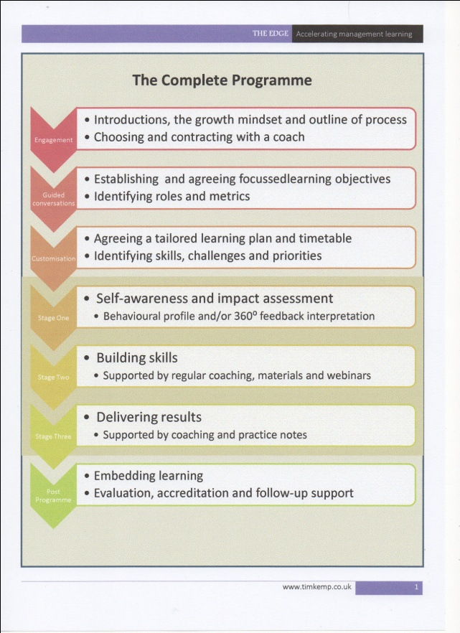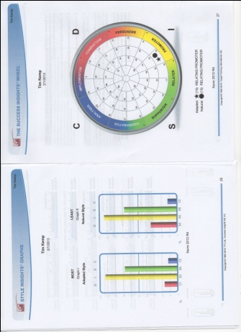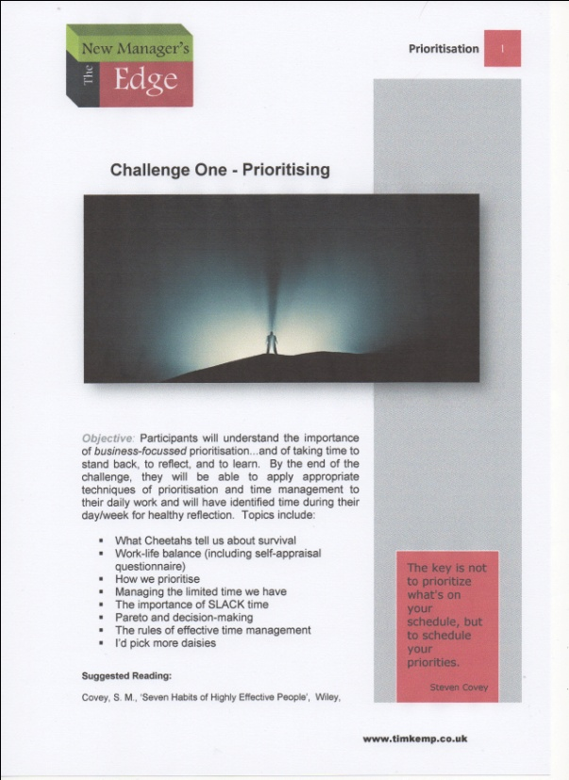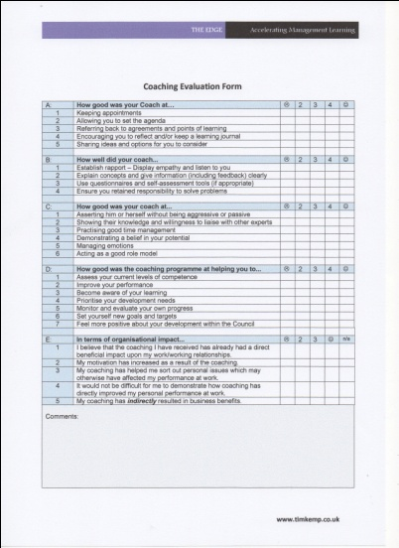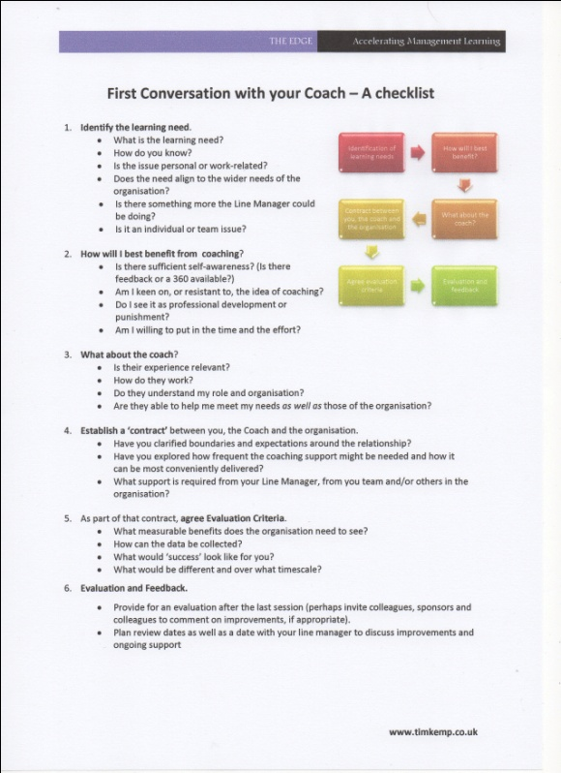

How it works...

Edge

The

New Manager’s

**Each programme includes:**

* Initial conversations with each participant and their Line Managers to identify and agree specific, relevant learning goals
* A behavioural assessment and/or 360⁰ feedback
* A series of challenges based around specific skills needs
* Regular support from a designated and chosen professional management coach, via Skype, phone, e-mail and text
* Regular webinars and podcasts
* A collation of relevant guidance notes, practical tips and techniques e-mailed to each participant monthly
* Regular reviews and clear evidence of progress towards learning goals
* CPD Accreditation

**The Edge** is different. It is designed to significantly reduce the amount of time it takes for new managers to become effective contributors. It will help them take on – and deal effectively with – the kinds of interpersonal dilemmas and challenges that so often undermine confidence and reduce performance.

**The Edge** is a cost-effective learning programme tailored to the individual learning needs of *each* participant. In addition to job-relevant support, it offers new managers the chance to work through a series of carefully chosen and organisationally-relevant challenges, with the active, focussed and regular support of a professional management coach.

The complete programme runs over 4-6 months and will achieve specific, organisationally-relevant and measurable learning objectives (chosen by the participant with his or her Line Manager).

The programme is fully accredited and participants will receive a certificate and CPD credit for the hours that they have undertaken.

On average, global executives believe they will need a 20% improvement in performance over and above current levels in order to meet their business objectives.

Organisations need to understand the dramatic shifts underway in the work environment and refocus on enabling higher levels of workforce performance

**2012 CEB Report ‘Breakthrough Performance in the New Work Environment’**

Each programme is tailored to the needs of both the organisation and the individual participant, with clear and measurable learning outcomes.

Alongside the range of skills challenges available to participants, we are happy to work within the context of any preferred competency framework. The current list of challenges include work on **Prioritisation**, **Teamwork**, **Followership**, **Evaluating performance**, **Being** **Proactive**, **Encouraging Innovation**, **Delegation**, **Decision-making**, **Feedback**, **Engagement**, and **Critical Conversations**. Specific challenges may also be designed to suit the particular needs of the individual or their organisation.

**Our approach to coaching**

We believe that sometimes people need sound advice as much as they need a good listening to. Our team of qualified and internationally experienced coaches will not shy away from sharing their business expertise and offering options whenever it is appropriate.

Our simple aim is to help people perform more confidently and with greater insight, as quickly as possible.

*"In a recent study, training alone improved leadership skills by 22%.*

*When combined with Coaching, improvement jumped to 77%."*

Fortune Magasine

**The Edge**

**Webinars**

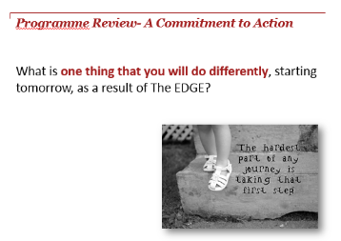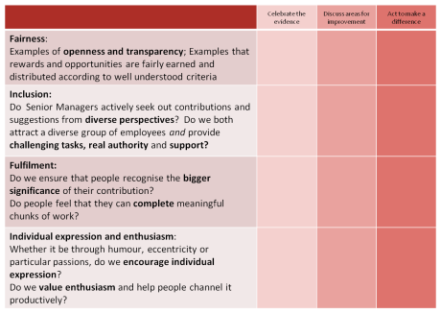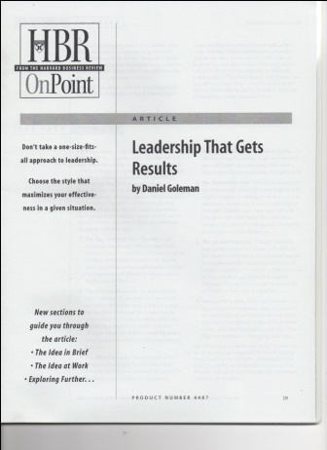FN99807-IMG05supervised and, by extensio

***Add CPD accreditation to CV! ☺***

***Webex conference on ‘Encouraging Innovation’ with other Edge participants – 4pm***

***Discuss performance issue with Coach, 9am***

**"I never cease to be amazed at the power of the coaching process to draw out the skills or talent that was previously hidden within an individual, and which invariably finds a way to solve a problem previously thought unsolvable."**

John Russell, Managing Director, Harley-Davidson Europe Ltd.

Edge

The

New Manager’s

From the opening conversation with The Edge team, to the receipt of CPD certification, our aim is to provide a tailored learning experience that provides meaningful advice, coaching and support ***on the job***. The challenging issues of people management are examined and tackled, enabling participants to build their confidence and skills with **real people in real time**.

With the support of an experienced coach, and a range of materials and articles designed to provide practical tips and techniques, new managers will also take on a series of challenges that are designed to stretch their skills in ways that will prepare them for greater responsibility.

***Induction to programme ... Choose Coach***

***Conversation with Line Manager and new Coach to agree learning goals and identify relevant challenges***

**The Edge**

**Webinars**

***Download Behavioural Profile***

Elements of the journey

along ‘The Edge’...

***Discuss today’s team meeting with Coach...***

***Skype call from Coach, 3pm***

**What each participants gets:**

* At least 9 hours of one-to-one coaching and professional advice via Skype, phone, e-mail and text, with reviews and clear evidence of progress towards learning goals
* The benefits of a behavioural assessment and/or 360⁰ feedback
* The chance to take on up to 6 challenges, based around the specific skills needed to work in a fast-changing environment
* Participation in regular webinars on relevant topics
* Monthly guidance notes, practical tips and techniques
* Electronic versions of key journal articles (e.g from the Harvard Business Review) and management updates
* CPD Accreditation

**What your organisation gets:**

* New Managers who take less time to achieve expected performance levels
* New Managers with more confidence and a more keenly developed insight into their role and responsibility
* More time for Senior Managers to focus on other things

**The key to our success is the quality of our coaches.**

**Participants choose from a range of experienced, insightful and pragmatic learning professionals who will help them develop useful skills…at the point when they are needed. ‘Just-in-time’ advice and guidance for people with work to do.**

**To reserve places e-mail**

[timkemp@timkemp.co.uk](mailto:timkemp@timkemp.co.uk)

Exceptional value for money

FN99807-IMG05

"I absolutely believe that people, unless coached, never reach their maximum capabilities."

Bob Nardelli, former CEO, Home Depot

The challenge of managing in the new environment is compounded by the fact that work is less supervised and, by extension,more autonomous; there are fewer managers to do the managing since the average span of control has grown from 6to 12 reports in a decade

Edge

The

New Manager’s

2015 Prices

|  |  |
| --- | --- |
| Fee  (6 month programme) | Per participant  (includes CPD Accreditation and certificate) |
| Individual manager | £1,885  €2,560  $2,853 |
| Up to 5 managers  in any one calendar year | £1,775  €2,410  $2,686 |
| Up to 10 managers in any one calendar year | £1,665  €2,261  $2,520 |
| More than 10 managers  in any one calendar year | £1,550  €2,105  $2,346 |

**Whether your need is to develop 1 or 101 new managers this month, we can help them ‘hit the ground thinking’.**

**To reserve places e-mail us or call**

[**timkemp@timkemp.co.uk**](mailto:timkemp@timkemp.co.uk)

**+44(0)7932 733903**

Organisations that want to book places for more than one manager in any one calendar year can choose to make one payment in advance or to receive monthly invoices.

The Edge Programme does not attract VAT outside the UK.

New cohorts are starting in September 2015